1. Create User from **UI** https://dev-qwallity.herokuapp.com/.
2. **Change user role in DB**

select * from users

WHERE username = 'Olya97';

UPDATE users

SET role_Id = '1'

WHERE Id=55555751;

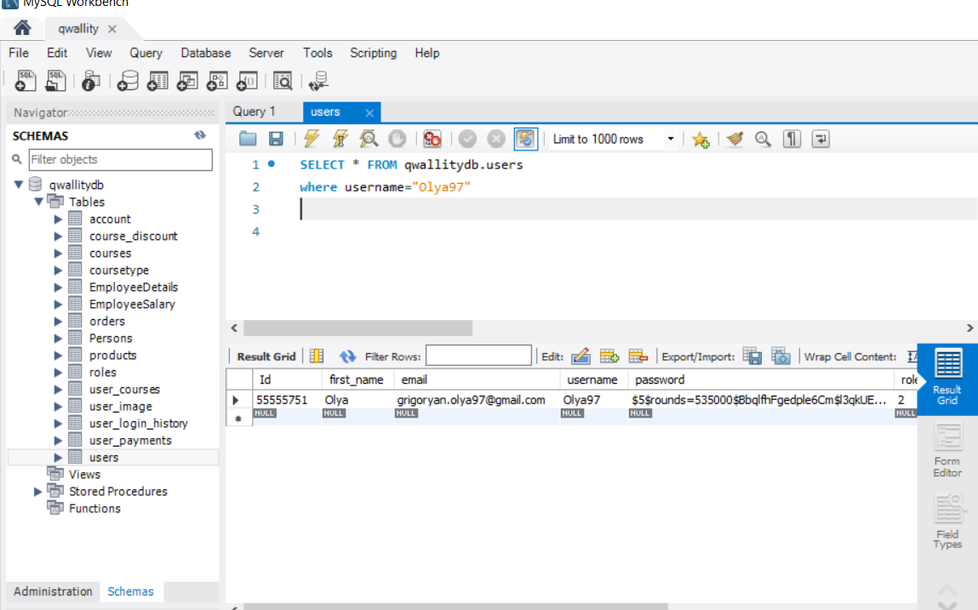

1. **Insert Course in database**

SELECT * FROM courses;

select * From coursetype;

INSERT INTO courses (title, body, author, date_created, coursetype, price)

VALUES("QA_autmation", "It_course", "Olya97", CURDATE(), 2, 100);

select * from courses

where title= "QA_autmation";

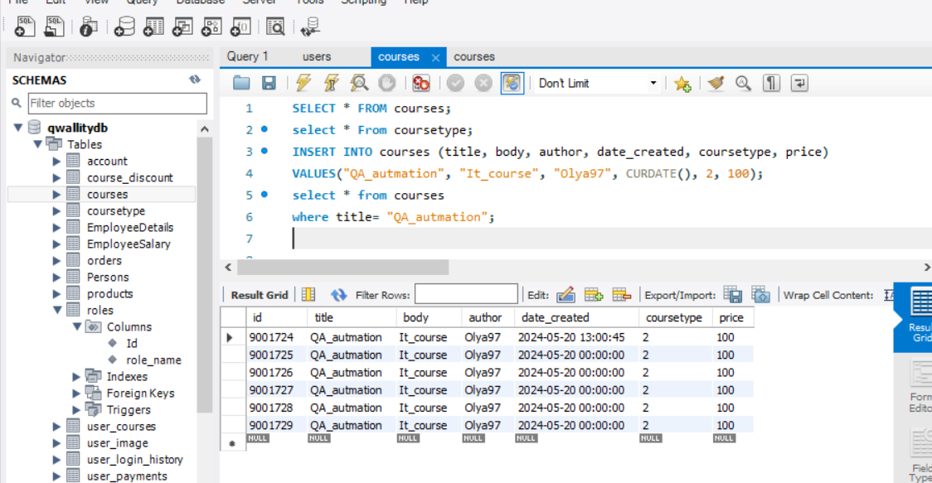

1. **Update Course name**

UPDATE courses

SET title="QA_Manual"

WHERE id=9001723;

select * from courses

where id= 9001723;

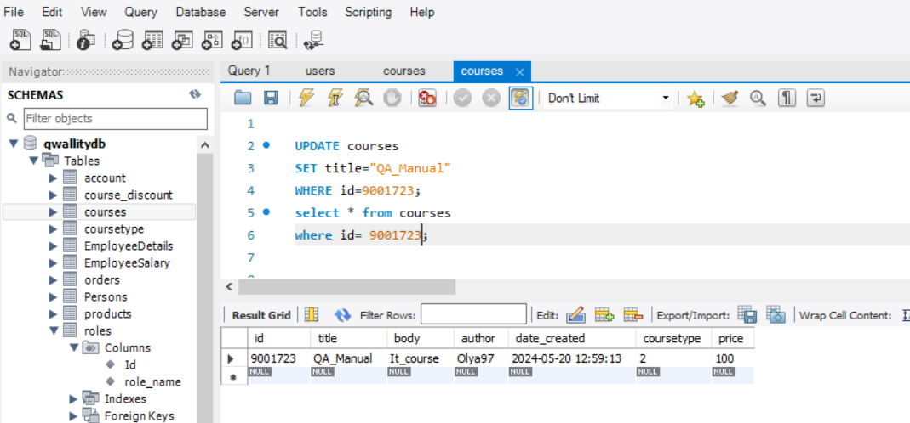

1. **Select all advanced courses**

SELECT * FROM courses

WHERE coursetype=2

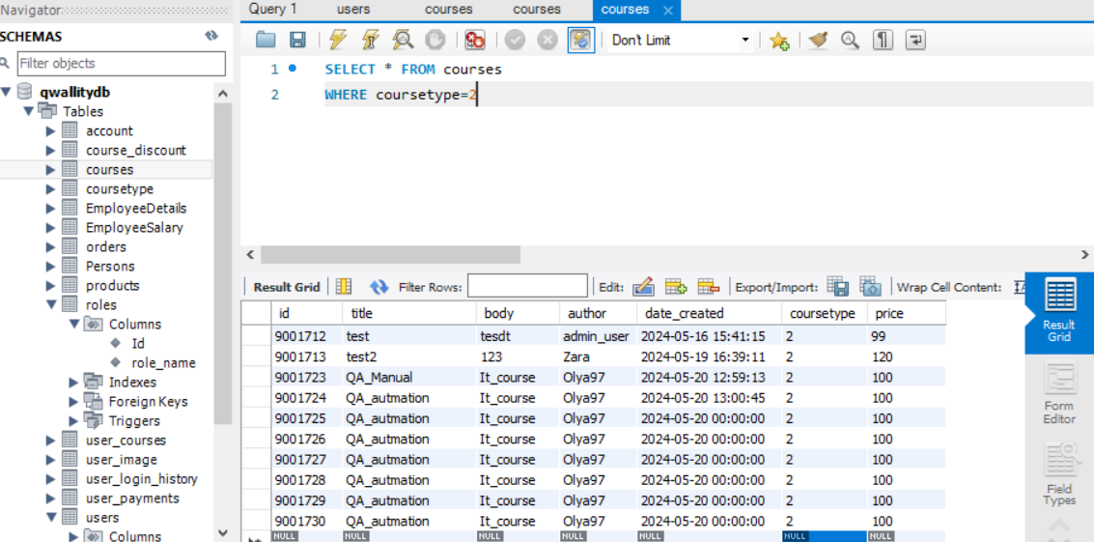

1. **Delete your added course**

DELETE from courses

WHERE id=9001723;

